**What is jenkins?**

Jenkins is a self contained, open source automation server which can be used to automate all tasks

related to building , testing and delivery activities.

Jenkins can be installed even on standalone be any machine with a java runtime envirowment (JRE)

Installed.

Jenkins is a tool for Implmenting CI-CD (Continuous Integration - Continuous Delivery)

**Stages in CI-CD**

Stage 1 : Continuous Download

Stage 2: Continuous Build

Stage 3: Continuous Deployment

Stage 4: Continuous Testing

Stage 5: Continuous Delivery

1-4 ----- Continuous Integration

5 ---- Continuous Delivery

**Create Instance in AWS**

1) Create the AWS Account

2) Login with your aws account

3) Click on Services

4) Click on EC2

5) Click on Instance

6) Click on launch instance

7) Select Ubuntu Server 20 (Free For Eligble)

8) Select t2.micro (Free For Eligble)

9) Click on Next: Configure Instance Details

10) Enter 3 in Number of Instance

11) Click on Add storage

12) Click on Next : Add Tags

13) Click on Next : Configure Security Group

14) Click on Add Rule

15) Select Type as All Traffic

16) Select Source as Anywhere

17) Click on Review and launch

18) If you are doing first time then you need to select Create a new key pair

19) Enter any name in key pair name

20) Click on download key pair

This key pair helps us to connect us to our data center.

21) Click on launch instance

22) Give all 3 instance proper name ( Dev Server, QA Server, Prod Server )

**How to Connect with the AWS Instance**

1) Select that Instance

2) Press Connect

3) You will get the SSH Command

4) Copy the SSH Command

5) Go to the folder where you have place your key then Open GITBASH in local machine

Git Bash you will get automatically when you have install GIT in your local machine.

6) Check your current location using pwd command

7) Now Paste the SSH Command in GITBASH

8) Just Type Yes

9) Now you are connect to the AWS Instance

Now we run any command that command run in the AWS Intance

Important Point : If you are not doing practice in AWS Stop all the instance.

**Install Jenkins in AWS Instance**

To install Jenkins the first thing we need java file so first we need to install java like we have done

in the local instance.

We need to download Java 1.8 or more.

1) Update the apt repository

sudo apt update

2) sudo apt install openjdk-8-jdk -y

3) Check the Java Version

java -version

4) Install Maven & Git

sudo apt-get install -y git maven

5) Check the Verion of Git & Maven

For Git : git --version

For Maven : mvn --version

6) Download & install Jenkins

Open Jenkins website (https://jenkins.io/download/)

Go to Long Term Support

Select Generic Java Package (.war)

We are selecting generic java package file because jenkins will install on those machine where java is

already install. If we have java install in windows machine jenkins will work. Only pre requirement is

java needs to be install.

For Windows we just need to click on the file and it will download automatically.

For Linux machine enter command wget and paste the url to download the file.

To get the URL right click on generic java package and click on copy link address.

(wget http://mirrors.jenkins.io/war-stable/latest/jenkins.war)

wget https://get.jenkins.io/war-stable/2.361.4/jenkins.war

11) Start the Jenkins.war file

java -jar jenkins.war

Every day if we want to run the jenkins we need to run this command. **[OR]**

curl -fsSL https://pkg.jenkins.io/debian-stable/jenkins.io.key | sudo tee \

/usr/share/keyrings/jenkins-keyring.asc > /dev/null

echo deb [signed-by=/usr/share/keyrings/jenkins-keyring.asc] \

https://pkg.jenkins.io/debian-stable binary/ | sudo tee \

/etc/apt/sources.list.d/jenkins.list > /dev/null

sudo apt-get update

sudo apt-get install jenkins

You can enable the Jenkins service to start at boot with the command:

sudo systemctl enable jenkins

You can start the Jenkins service with the command:

sudo systemctl start jenkins

You can check the status of the Jenkins service using the command:

sudo systemctl status Jenkins

12) Access Jenkins Home Page

Select DEV Instance & Press Connect.

Copy the Domain Name On 4th point.

Paste the Domain name in the browser and in the end enter :8080 with the default port number.

We can access the jenkins with dev server Public IP.

Copy the public ip of the dev server and paste the ip address in the browser and in the end enter :8080 with the default port number.

Public

13) Unclock Jenkins

When we are installing jenkins it will automatically give you the password in the github terminal.

Copy the password and paste the browser.

You will get the password on the step 11

14) Press Install Suggested Plugins

15) Create First admin user

The first user which we create here is the admin user of the jenkins.

Click on save and continue.

Click on save and finish

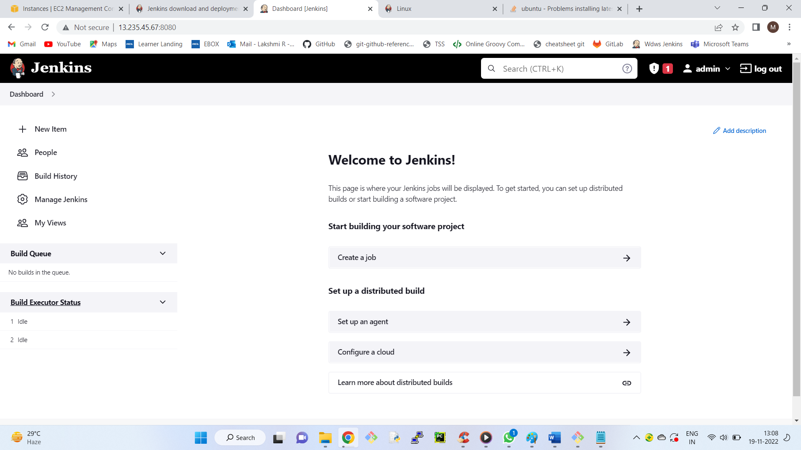

**Create Sample Job**

Build tab

Click on execute Shell

In Command Box Enter echo " Hello Jenkins"

Click on Console Output